FINALTERM EXAMINATION
Fall 2009
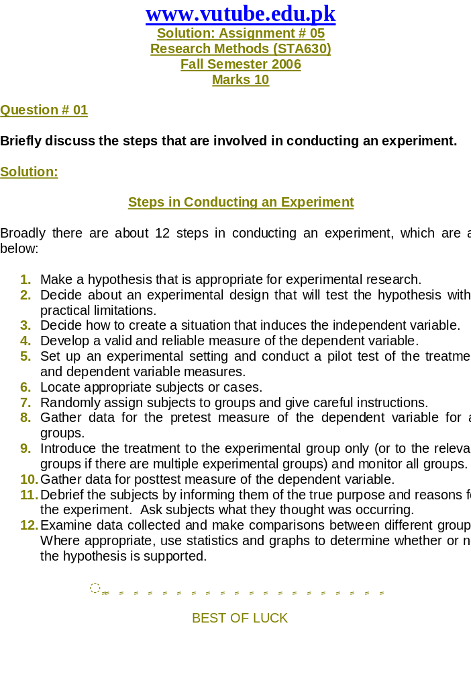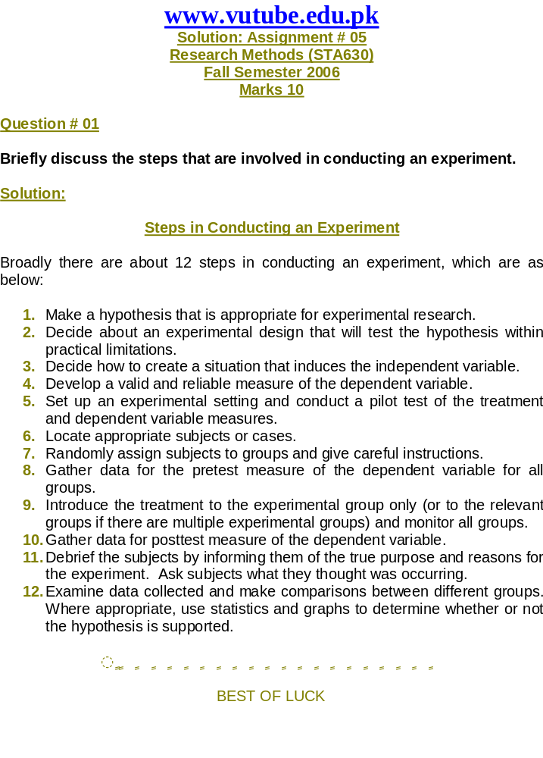
STA630- Research Methods

Question No: 1 ( Marks: 1 ) - Please choose one
The part of the action research spiral that differentiates this research methodology from other kinds of research is;
► Looking at multiple sources of data.
► Taking action based on results. Correct
► Thinking about or analyzing data in more than one way.
► The kinds of data that are collected.

Question No: 2 ( Marks: 1 ) - Please choose one
Individuals who engage in action research are most concerned with:
► Supporting the way things are being done.
► Publishing results Correct
► Proving a hypothesis
► Improvement

Question No: 3 ( Marks: 1 ) - Please choose one
Research may differ along a series of dimensions. Which of the following may be applied to this statement?
► The level of manipulation used to elicit data collection.
► The data-collection technique. Correct
► The type of data collected.
► Type, technique and manipulation of data collection.

Question No: 4 ( Marks: 1 ) - Please choose one
Which of the following statements best defines hypothesis?
► A quantitative study.
► A tentative prediction of the results of the research. Correct
► A qualitative research design.
► The operational definition of the study.

Question No: 5 ( Marks: 1 ) - Please choose one
What is the first step in the research process?
► Problem definition Correct
► Define broad problem area
► Theoretical framework
► Preliminary data collection

Question No: 6 ( Marks: 1 ) - Please choose one
When there is a need of generating new ideas for hypotheses or to interpret the results of some research, which one is the best research deign?
► Experiment
► Surveys
► Focus group discussion Correct
► Communication analysis

Question No: 7 ( Marks: 1 ) - Please choose one
Which of the following is an example of deception in business research?
► The obtaining of company material without permission.
► The researcher wearing a disguise during an observation.
► The researcher representing their research as being about a different topic. Correct
► The researcher failing to ask permission to interview someone.

Question No: 8 ( Marks: 1 ) - Please choose one
Which of the following is least likely to occur as an ethical problem with electronic research?
► Privacy could be invaded.
► People are not likely to be able to stop once they have begun participating. Correct
► Debriefing could be avoided.
► Informed consent cannot be completely monitored.

Question No: 9 ( Marks: 1 ) - Please choose one
All of the following are unethical issues, EXCEPT;
► Invoicing irregularities
► Avoiding legal liability
► Misrepresenting results
► Seeking permission for entry Correct

Question No: 10 ( Marks: 1 ) - Please choose one
Which of the following is the difference between measures and indicators?
► Measures are unambiguous quantities, whereas indicators are devised from common sense understandings.
► Indicators have a more direct relationship to the underlying concept than measures. Correct
► Measures are intuitively devised and then applied as if they were direct indicators of a concept.
► Indicators are unambiguous quantities, whereas measures are subjective and value-laden.

Question No: 11 ( Marks: 1 ) - Please choose one
The extent to which a test provides scores that are meaningful, appropriate, or useful is referred to as;
► Reliability
► Accuracy Correct
► Internal validity
► Validity

Question No: 12 ( Marks: 1 ) - Please choose one
Which of the following functions is performed by the Ordinal scale?
► Categorize
► Distance
► Order Correct
► Unique origin

Question No: 13 ( Marks: 1 ) - Please choose one
What is the difference between interval/ratio and ordinal variables?

► Ordinal data can be rank ordered, but interval/ratio data cannot.
► The distance between categories is equal across the range of interval/ration data.
► Interval/ratio variables contain only two categories.
► Ordinal variables have a fixed zero point, whereas interval/ratio variables do not. Correct

Question No: 14 ( Marks: 1 ) - Please choose one
Which of the following statement refers to cross-sectional design?
► A comparison of two or more variables over a long period of time
► The collection of data from more than one case at one moment in time Correct
► One that is devised when the researcher is in a bad mood
► A study of one particular section of society, e.g. the middle classes

Question No: 15 ( Marks: 1 ) - Please choose one
Which of the following is TRUE for research plan?

► It should be detailed.
► It should be given to others for review and comments.
► It sets out the rationale for a research study.
► All of the given options Correct

Question No: 16 ( Marks: 1 ) - Please choose one
Which of the following typically does NOT apply to observers in survey research studies?
► They observe predetermined activities.
► They are participant observers.
► They obtain information by watching rather than asking. . Correct
► They must be careful not to influence the activities they observe.

Question No: 17 ( Marks: 1 ) - Please choose one
Which of the following is not an advantage of the self-completion questionnaire over the structured interview?
► It is cheaper to administer.
► It is quicker to administer.
► It is easier to prompt the interviewee.
► It is easier to remove interviewer effects. . Correct

Question No: 18 ( Marks: 1 ) - Please choose one
Mr. X has coded his observations to hide the identity of each of the three participants in his study. He is ensuring;
► protection from harm
► confidentiality
► informed consent
► anonymity . Correct

Question No: 19 ( Marks: 1 ) - Please choose one
The cover letter to a questionnaire study should contain all of the following, EXCEPT;
► A list of participants
► A self-addressed, stamped envelope
► Purpose of the study
► Reasons to respond . Correct

Question No: 20 ( Marks: 1 ) - Please choose one
Teachers are advised to predict the results of student attitudinal questionnaires, because;
► It will help them decide if students answered truthfully.
► It gives them a point of comparison against which to judge actual responses. Correct
► It will allow them to apply statistical procedures in analyzing results.
► It helps them familiarize themselves with the questionnaires.

Question No: 21 ( Marks: 1 ) - Please choose one
In conducting an action research study of "student's organizational skills during class in a particular school", which of the following would NOT likely to provide useful data?
► Interviews with teachers
► Classroom observations
► Parent surveys Correct
► Teacher's journal entries

Question No: 22 ( Marks: 1 ) - Please choose one
Why it is helpful to keep a research diary or log book while you are conducting your project?
► To give you something to do in the early stages of your research when nothing is happening.
► Because funding councils generally demand to see written evidence that you were working every day during the period of the research.
► To keep a record of what you did and what happened throughout the research process. Correct
► It can be added to your dissertation to ensure that you reach the required word limit.

Question No: 23 ( Marks: 1 ) - Please choose one
Which of the following is likely to happen if clear instructions are not given as to how the respondent should answer the question?
► Respondents may delete inappropriate answers rather than select appropriate ones.
► Respondents may choose only one answer when they need to choose as many as apply.
► Respondents may complete questions that are not relevant to them.
► All of the given options. Correct

Question No: 24 ( Marks: 1 ) - Please choose one
Which of the following is NOT a suitable topic for research using a diary?
► The amount of time managers spend on particular activities.
► The frequency with which managers undertake particular tasks.
► The locations in which a trade union representative has discussions with individual members. Correct
► The volume of female managers in the retail industry.

Question No: 25 ( Marks: 1 ) - Please choose one
Which of the following represents excellent advice for conducting an interview?
► Listen more and talk less
► Don't interrupt
► Don't be judgmental about the interviewee's beliefs or views
► All of the given options Correct

Question No: 26 ( Marks: 1 ) - Please choose one
Which of the following is an example of a dilemma that might face feminist business researchers conducting qualitative interviews with women?
► What role to adopt while interviewing male managers?
► How many female employees should be interviewed for a representative sample? Correct
► How to overcome the issue of false consciousness?
► What data to use while publishing findings?

Question No: 27 ( Marks: 1 ) - Please choose one
Which of the following sampling strategies was used when the three students with the highest GPAs were selected?
► Extreme case Correct
► Snowball
► Maximum variation
► Normal case

Question No: 28 ( Marks: 1 ) - Please choose one
Which type of sampling strategy is exemplified by selecting two types of individuals: those who are extremely happy and those who are extremely sad?
► Snowball
► Intensity Correct
► Homogeneous
► Purposive

Question No: 29 ( Marks: 1 ) - Please choose one
The logic of purposive sampling is:
► To use participants because the researcher has access to them.
► That a random sample can generalize to a population.
► That a few information-rich participants studied in depth yield many insights about a topic. Correct
► To include all participants, even though they are not all relevant to the problem.

Question No: 30 ( Marks: 1 ) - Please choose one
Using a sample of 30 participants, a researcher finds a correlation of 0.30 between two variables. The relationship is not statistically significant. If the researcher were to triple her sample size, which of the following is most likely?
► The correlation would be statistically significant.
► The correlation would be larger. Correct
► The correlation would be smaller.
► Nothing is likely to change.

Question No: 31 ( Marks: 1 ) - Please choose one
Which of the following steps begins the analysis of qualitative data?
► Reading and memoing
► Describing the content and participants Correct
► Classifying and interpreting
► Data management

Question No: 32 ( Marks: 1 ) - Please choose one
Which of the following represents the most general conceptualization in qualitative data analysis?
► Word
► Topic Correct
► Category
► Pattern

Question No: 33 ( Marks: 1 ) - Please choose one
Which of the following BEST differentiates data analysis from interpretation?
► Interpretation requires more conceptual and integrative thinking than data analysis.
► Interpretation involves computerized analysis of data.
► Data analysis is explanatory and interpretation is conceptual. Correct
► Data analysis involves conceptualization but interpretation does not.

Question No: 34 ( Marks: 1 ) - Please choose one
The statistic used to determine the relationship between two variables is:
► Analysis of covariance
► Chi square
► Standard deviation Correct
► Pearson "r"

Question No: 35 ( Marks: 1 ) - Please choose one
Which of the following is NOT a control procedure used in causal-comparative research?
► Matching.
► Subgroups.
► Chi square. Correct
► Analysis of covariance.

Question No: 36 ( Marks: 1 ) - Please choose one
Which of the following best describes qualitative data coding?
► Adding all of the scores together and describing them statistically.
► Identify data segments that contain general episodes.
► Numerically representing the concepts identified by the participants. Correct
► Dividing data in parts that represent single thoughts.

Question No: 37 ( Marks: 1 ) - Please choose one
The bivariate tables derived from trivariate table are called;
► Sub table
► Bivariates
► Partials
► Correlational tables Correct

Question No: 38 ( Marks: 1 ) - Please choose one
Quasi-experimental research is used because:
► Random selection is not possible
► Neither random selection nor random assignment is possible
► Random assignment is not possible Correct
► There are no comparison groups available

Question No: 39 ( Marks: 1 ) - Please choose one
A researcher believes that the effects of a treatment will be different for males and females. Which one is the best method to test this possible interaction?
► Single-subject design
► Factorial design
► Time-series design Correct
► Quasi-experimental design

Question No: 40 ( Marks: 1 ) - Please choose one
The influence of the researcher's background, personal experiences, preferences, or attitude on an interview or observation is technically defined as:
► Participant bias
► Observer bias
► Observer effect Correct
► Nonparticipant effect

Question No: 41 ( Marks: 1 ) - Please choose one
On which component of his field notes did Mr. Majid focused when he expressed in his notes his thoughts and ideas about what he observed?
► Description Correct
► Reflection
► Protocol
► Formal data

Question No: 42 ( Marks: 1 ) - Please choose one
Which of the following is linked with an abstract model of underlying relations or causal mechanism?
► Historical comparative research Correct
► Social research
► Action research
► Experimental research

Question No: 43 ( Marks: 1 ) - Please choose one
In which section is the researcher allowed greater flexibility to express opinions, discuss implications for educational practice, and suggest additional research?
► Review of the literature
► Significance of the study
► Results
► Discussion Correct

Question No: 44 ( Marks: 1 ) - Please choose one
Which of the following can be referred as Haphazard Sampling?

► Convenience Sampling
► Purposive Sampling
► Snowball Sampling Correct
► Quota Sampling

Question No: 45 ( Marks: 1 ) - Please choose one
An important issue in index construction is to------------items.

► Reconstruct
► Codify
► Measure
► Weight Correct

Question No: 46 ( Marks: 1 ) - Please choose one
Which of the following elements of Observation is/are included in Non Reactive research?

► External Appearance
► Count Behaviors
► Time Duration
► All of the given options Correct

Question No: 47 ( Marks: 1 ) - Please choose one
Secondary /existing data may include which of the following?

► Official documents
► Personal documents
► Archived research data Correct
► All of the given options

Question No: 48 ( Marks: 1 ) - Please choose one
Which of the following major problem exist with non respondents in survey research?

► They tend to be alike in many ways.
► Data cannot be analyzed for only part of a sample.
► They cannot be found to determine if they are similar to respondents. Correct
► They may have different opinions than respondents.

Question No: 49 ( Marks: 1 ) - Please choose one
Which of the following advantage differentiates personal interview from mail, internet and telephonic survey?
► Cheaper
► Expensive
► Easier Correct
► Inexpensive

Question No: 50 ( Marks: 1 ) - Please choose one
Which one of the following methods offers the lowest degree of geographic flexibility?
► Mail survey
► Telephone interview
► Door-to-door personal interview Correct
► Internet survey

Question No: 51 ( Marks: 1 ) - Please choose one
Which of the following survey research methods is the most expensive?
► Telephone interview
► Mail survey
► Door-to-door personal interview Correct
► Mall intercept personal interview

Question No: 52 ( Marks: 1 ) - Please choose one
When a respondent tells the interviewer that he reads "Best Selling English News Paper" on a daily basis so that he can impress the interviewer, this is an example of:

► Administrative bias
► Interviewer bias
► Submission bias
► Response bias Correct

Question No: 53 ( Marks: 1 ) - Please choose one
All of the following are stages in the selection of a sample EXCEPT:

► Determine sample size
► Analyze data Correct
► Conduct fieldwork
► Select a sampling frame

Question No: 54 ( Marks: 1 ) - Please choose one
A stratified sample in which the number of sampling units drawn from each stratum is in proportion to the population size of that stratum is called a:

► Balanced stratified sample Correct
► Proportional stratified sample
► Cluster sampling
► Convenience sample

Question No: 55 ( Marks: 1 ) - Please choose one
Assigning males the value of zero and females the value of one in a database to record the gender of the respondents is an example of:

► Coding Correct
► Editing
► Verification
► Test tabulation

Question No: 56 ( Marks: 1 ) - Please choose one
Arranging data into a table is called:

► Analysis
► Frequency
► Interpretation
► Tabulation Correct

Question No: 57 ( Marks: 1 ) - Please choose one
A researcher interested in a data matrix that displays the frequency of some combination of possible responses to multiple variables should construct a:

► Contingency table
► Regression equation
► Marginal table
► None of the given options Correct

Question No: 58 ( Marks: 1 ) - Please choose one
When initial subjects are selected randomly and additional subjects are obtained from recommendations of names from the initial subjects, this sampling technique is called:

► Judgment sample
► Snowball
► Convenience sample
► Cluster sample Correct

Question No: 59 ( Marks: 1 ) - Please choose one
When different interviewers are used in a pretest from those used in the posttest and this produces different results in the study, this is an example of a:

► History effect
► Mortality effect
► Instrumentation effect Correct
► Cohort effect

Question No: 60 ( Marks: 1 ) - Please choose one
Which of the following is a threat to the internal validity of experiment using a repeated measures design?

► Instrumentation effect Correct
► Cohort effect
► Attrition effect
► All of the given options

Question No: 61 ( Marks: 1 ) - Please choose one
Most threats to ________ are taken care of by the experiment’s design, while most threats to ________ need to be taken care of by the designer of the experiment.

► Internal validity, external validity
► External validity, internal validity Correct
► Randomization, reliability
► Reliability, randomization

Question No: 62 ( Marks: 1 ) - Please choose one
In which of the following, the beginning and end are not clear. The interview can be picked up later?

► Survey Interview
► Field Interview Correct
► Deception
► None of the given options

Question No: 63 ( Marks: 1 ) - Please choose one
The written set of guidelines that describes an outline of topics to be covered by a focus group moderator is called a:

► Discussion guide Correct
► Concept test
► Case study
► All of the given options

Question No: 64 ( Marks: 1 ) - Please choose one
Which of the following is a disadvantage of focus groups?

► Requires objective, sensitive, and effective moderators Correct
► May not be useful for discussing sensitive topics
► High cost
► All of the given options

Question No: 65 ( Marks: 3 )
What do we write in executive summary of a research report?

Executive Summary of Research Report:

It is very important part of the report. And it is observed that mostly managers read summary report normally and rest members read whole report.

Executive summary write in four elements:
1. First objective of the report is mentioned and then most important part and specific
reason of the project.

2. Main results are presented including purpose.
3. The conclusions of the report based on results.
4. The suggestions on the basis of conclusions that action will be taken
.

Question No: 66 ( Marks: 5 )
What is different Ethical dilemma of Field research?

Ans

Ethical Dilemmas of Field research

The dilemmas are made when the researchers are alone in fields and have very much little time to make decision. The ethical dilemmas raises when a field researcher get involve into lives of other people.
These dilemmas arise suddenly when some one interacting in the field with others.
Some of these dilemmas:

Confidentiality:

In field some learns a lot and some not very much, similarly some one has some confidential data and don’t want to share with anyone which creates it.

Deception:

Deception may arise because of false role, name or identity, some agreed with some one and some one not some time. So because of these things this occurs.

The powerful:

Field researchers are normally those who are without power in society e.g., street people, the poor, and powerful people block their way and criticized them

Involvement with deviations:

Some researchers conduct research on deviants who engage in illegal behavior. This type of things create dilemma due to involvement in illeal activities.

Last field reports:

At the end of research, the knowledge, a researcher gains and his final report or thesis can make a dilemma between the right of privacy and the right to know. In last report if researcher hides some fact or not give the true picture of research then it creates a dilemma.

Question No: 67 ( Marks: 10 )
By using Likert scale, how would you score a positive and negative statement? Give one example to explain your answer.

Ans:

Likert scale is bused on 5 responses therefore lets take an example and constructed number of statements for each element with five responses.

- Strongly Agree
- Agree
- Undecided
- Disagree
- Strongly Disagree

These statements could be of both positive and negative.

For positive statements

We score from 5 to 1 i.e. strongly agree to strongly disagree

For negative statement

Score will be reversed i.e 1 to 5

1 for strongly agree
2 for agree
3 for undecided
4 for disagree
5 for strongly disagree

Question No: 68 ( Marks: 10 )
How observations can be structured in non-reactive research?

Ans

In non reactive research, the people or the things that are being studied are not aware of that.

Non reactive research is structured as follow:

PHYSICAL TRACES:

• Erosion:

In erosion wear and tear has a greater use. For example, a researcher examines that children like those toys which are worn out and children have more interest in them.

ARCHIVES:

• Running Records:

In these records many researches can be done.
For example, a record of thieves in jail record of daily marriages. Etc.

• Other Records:

Irregular records can give a lot
. For example, look into the number of reams of paper purchased by a college principal’s office for the last 10 years and compare it with students’ enrollment.

OBSERVATIONS:

• Time Duration:

By this type of research, researcher can check the interest of people indifferent things. Like time spending in seeing the signboards on the road.

• External Appearance:

It shows the behavior of people in social factor that how they want to look.
How people appear may indicate social factors. For example, a
researcher can examine that in university how much percentage of student’s wear casual dressing and how much formal.

